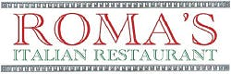

# **Roma's Italian Restaurant**

112 W Noble Ave, Guthrie, OK 73044

405-260-1552

Tue-Sun 4:30pm-9:00pm

## Pizza Cheese Personal

Classic cheese $10.99

create your own pizza each topping $2.00

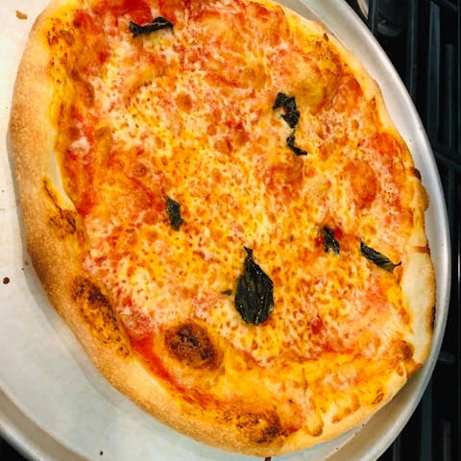

Supreme Pizza $16.99

Roma Meat Lovers Pizza

Topped with cheese, bacon, ham, and pepperoni. $19.99

Roma White Pizza

A sauceless pie topped with ricotta, mozzarella, and parmesan cheese. $17.99

Gluten Free Pizza

Gluten-free pizza with classic cheese. $10.99

## Appetizers

Fried Mozzarella Cheese $6.95

Fried Cheese Ravioli

Ravioli stuffed with classic cheese. $8.95

Fried Calamari

Flash fried squid, crunchy on the outside and simply perfect on the inside. Kick it up a notch with a squeeze of lemon. $14.99

Shrimp Napoleon $12.99

Sliced Italian Sausage $10.99

## Salads

House Salad

A mix fresh seasonal greens. $4.99

Caesar Salad

Fresh romaine lettuce tossed with homemade caesar dressing & croutons. $8.99

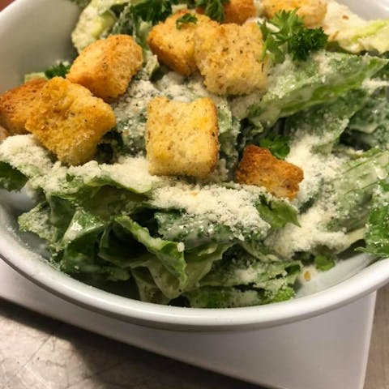

Roma's Salad

Fresh mixed greens, black olives, mushrooms, tomatoes & mozzarella cheese. $8.99

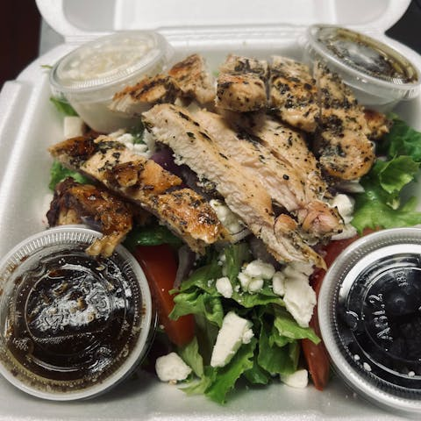

Greek Salad

Balsamic oil & vinegar, lettuce, tomatoes, black olives, red onions & feta cheese. $8.99

## Side Orders

Marinara Sauce $2.50

Olive Oil with Garlic & Basil Sauce $2.50

## Calzones & Strombolis

Calzone

Sausage, mozzarella and ricotta cheese wrapped in pizza crust, served with marinara sauce.$15.99

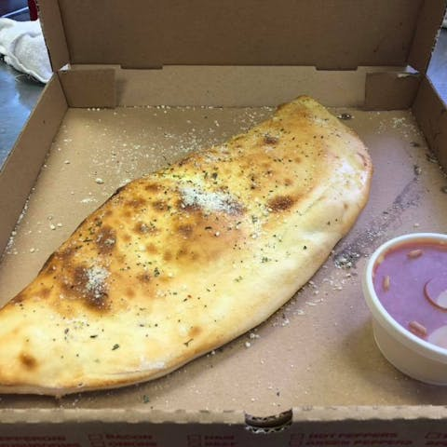

Stromboli

Pepperoni, sausage and mozzarella cheese wrapped in pizza crust, served with marinara sauce. $15.99

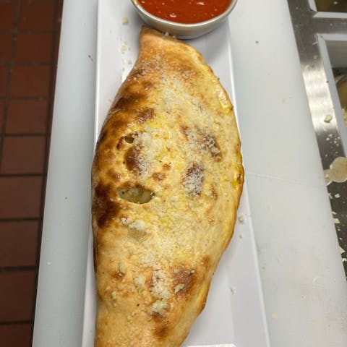

## Sandwiches

Meatball Parmigiano Sub $14.99

Philly Steak Sandwich

Baked bread topped with sautéed onions, peppers, mushrooms, mozzarella cheese & sliced steak. $14.99

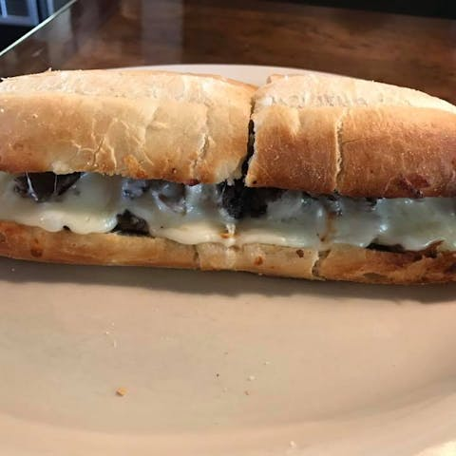

## Pasta Specialties

Fettuccine Primavera

Served with mixed vegetables with alla Panna sauce. $17.99

Tortellini Alfredo

Cheese tortellini with alfredo sauce $15.99

Tortellini Alla Panna

Cheese tortellini with pink sauce. $15.99

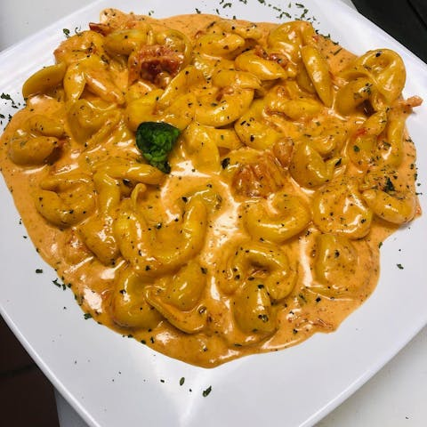

Fettuccine Alfredo

Creamy alfredo sauce served over fettuccine.$15.99

Sausage Pizzola Pasta

Onions, mushrooms, marinated over spaghetti. $16.99

Spaghetti with Marinara Sauce

Spaghetti tossed in homemade marinara sauce.$13.99

Spaghetti with Mushrooms $15.99

Spaghetti with Meatballs $15.99

Spaghetti with Meat Sauce $15.99

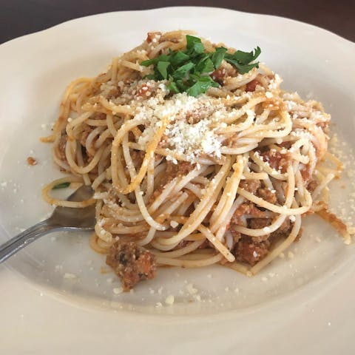

Spaghetti The Works

Includes mushrooms, meatballs & meat sauce.$17.99

Spaghetti Carbonara

Sauteed with mushrooms, ham, and tomatoes in a rich cream sauce with a touch of marinara over fettuccine.$17.99

Sausage Pepper Parmigiano

Served with green bell peppers, red sauce, topped with mozzarella cheese with spaghetti.$17.99

Roma Special Combo

Chicken parm, lasagna, fettuccine alfredo.$19.99

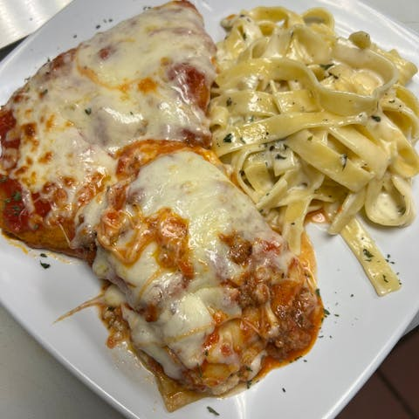

Spinach Ravioli with Chicken

Served with alla Panna sauce. $17.99

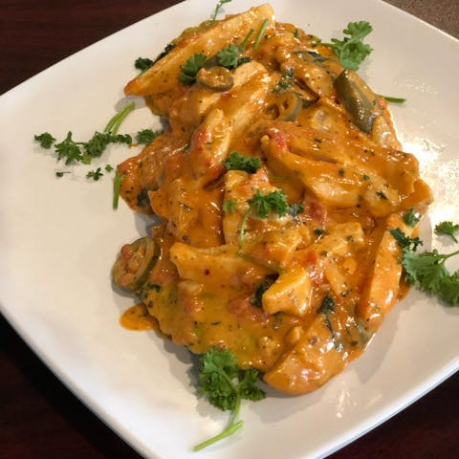

## Baked Pasta

Baked Ziti

Penne pasta, ricotta cheese & marinara topped with mozzarella. $14.99

Cheese Ravioli

Jumbo ravioli topped with marinara sauce & mozzarella cheese.$14.99

Lasagna $17.99

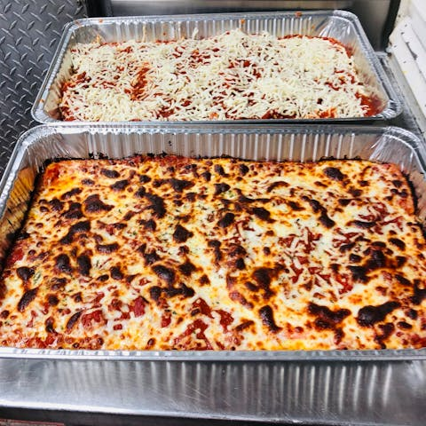

Manicotti

Pasta stuffed & rolled with ricotta cheese, topped with marinara sauce & mozzarella cheese. $14.99

Meat Ravioli

Jumbo ravioli topped with marinara sauce. $15.99

Canelloni

Pasta stuffed and rolled with spinach and veal topped with mixed sauce alfredo and marinara topped with mozzarella cheese. $15.99

Pasta Trio

Combination of lasagna, manicotti, and meat ravioli over marinara sauce, topped with mozzarella chees and baked. $17.99

## Chicken Dishes

Served with house salad.

Tortellini Modo Mio with Chicken

Tomatoes, broccoli, mushrooms, white wine sauce with lemon. $18.99

Chicken Fettuccine Alfredo

Creamy white wine sauce served over fettuccine topped with chicken. $18.99

Chicken Damabianca

With mushrooms over spaghettini with alfredo sauce. $18.99

Chicken & Broccoli

Sliced chicken & broccoli, cheese tortellini with alfredo sauce. $18.99

Chicken Parmigiana

Sauteed in marinara, served over spaghetti. $18.99

Chicken Diavolo Spicy

Spicy red sauce, tomatoes, peppers, onions with spaghetti. $18.99

Chicken Pomodoro

Served with diced tomatoes over penne and red sauce. $18.99

Chicken Piccata

With capers, white wine lemon sauce. $17.99

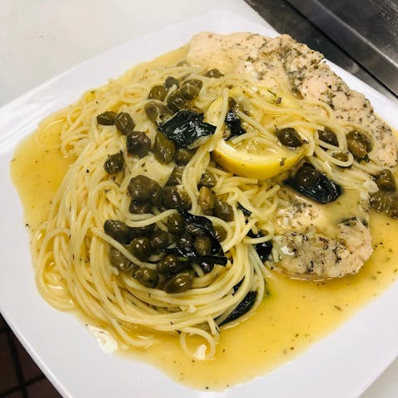

Mayor’s Special

Chicken, sausage, ham, tomatoes, olives, artichoke with Alla Panna sauce over pasta $18.99

Chicken Marsala

Served with mushrooms & marsala wine over spaghetti. $17.99

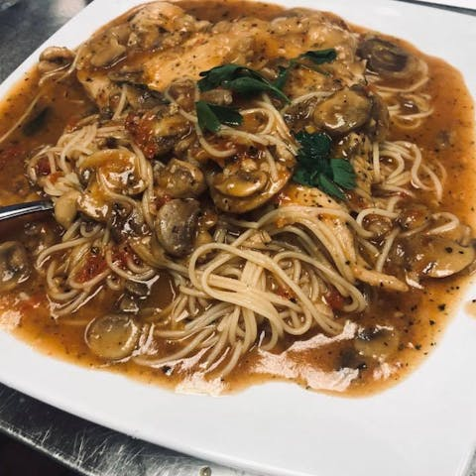

Shrimp & Chicken Alfredo $21.99

Grilled Chicken w/ Vegetables $17.99

## Veal

Served with House salad.

Veal Parmigiano

Breaded veal served with mozzarella, over spaghetti marinara $18.99

Veal Marsala

Breaded veal served with mushrooms & marsala wine sauce over spaghetti. $18.99

Veal Piccata

Breaded veal, capers, white wine lemon sauce. $18.99

Veal Diablo

Breaded veal, onions, peppers, tomato, spicy red sauce. $18.99

## Seafood

## Served with house salad.

Salmon Ala Blanco

Served with tomatoes, broccoli, mushrooms, covered with Alfredo sauce with spaghetti pasta. $19.99

Tilapia Ala Blanco

Served with tomatoes, broccoli, mushrooms, covered with Alfredo sauce with spaghetti pasta.$19.99

Grilled Salmon with Vegetables $19.99

Salmon Primavera

Sautéed with alla pana and mixed vegetables & linguine pasta. $19.99

Linguine Tutomare

Mixed seafood in alla Panna sauce, over linguine pasta. $19.99

Bella Mia

Salmon, grilled shrimp, broccoli, mushrooms, tomatoes, creamy sauce. $19.99

Shrimp Scampi

With white wine lemon sauce over linguine pasta. $18.99

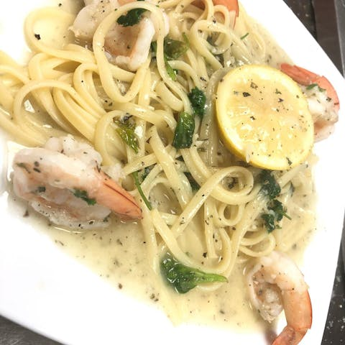

Shrimp Scallopine

Shrimp, scallops and mussels sautéed in sherry wine, with light marinara sauce. $19.99

Shrimp Diablo Spicy

Onions, peppers, and tomatoes, over linguine pasta with red sauce. $18.99

Shrimp & Scallops Alfredo

Shrimp, scallops, with fettucine pasta and alfredo sauce. $18.99

Salmon Piccata

Capers, white wine lemon sauce over spaghetti pasta. $19.99

Seafood Ravioli

With pink and alla panna sauce. $18.99

## Seniors Menu

## 65 & older. Senior menu includes drinks.

Senior Lasagna $12.99

Senior Manicotti

A large tube of fresh pasta stuffed with a blend of soft cheese. $12.99

Senior Baked Ziti $12.99

Senior Cheese Ravioli $12.99

Senior Spaghetti with Meatballs $12.99

Senior Spaghetti w/Meat Sauce $12.99

## Kids Menu

2 to 10 years. Kids menu includes drinks.

Kid's Lasagna $8.99

Kid's Manicotti

A large tube of fresh pasta stuffed with a blend of soft cheese. $8.99

Kid's Baked Ziti

Ziti with mozzarella and tomato sauce baked to perfection in our oven. $8.99

Kid's Cheese Ravioli

Ravioli stuffed with classic cheese. $8.99

Kid's Spaghetti with Meatballs

Spaghetti topped in our homemade meatballs. $8.99

Kid's Spaghetti with Meat Sauce

Spaghetti with beefy, juicy sauce.$8.99

Kid's Fettuccine Alfredo

Kids can't get enough of fettuccine in a creamy alfredo sauce $8.99

Kid's Tortellini alla Panna $8.99

## Desserts

Italian Cream Cake $6.99

Lemon Mascarpone $5.99

Cheesecake

Ask server for flavors. $5.99

Cannoli

Delicious tube of fried dough, filled with a sweet, creamy ricotta filling. $5.99

Tiramisu

A delicious coffee-flavored Italian dessert. Ladyfingers dipped in coffee, layered with a whipped mixture of eggs, sugar & mascarpone cheese, flavored with cocoa.$5.99

## Beverages

Soda

Nothing like a cold soda to go with your pizza.$3.49

Coffee $3.49

Iced Tea $3.49

Sweet Tea $3.49

Water $1.00